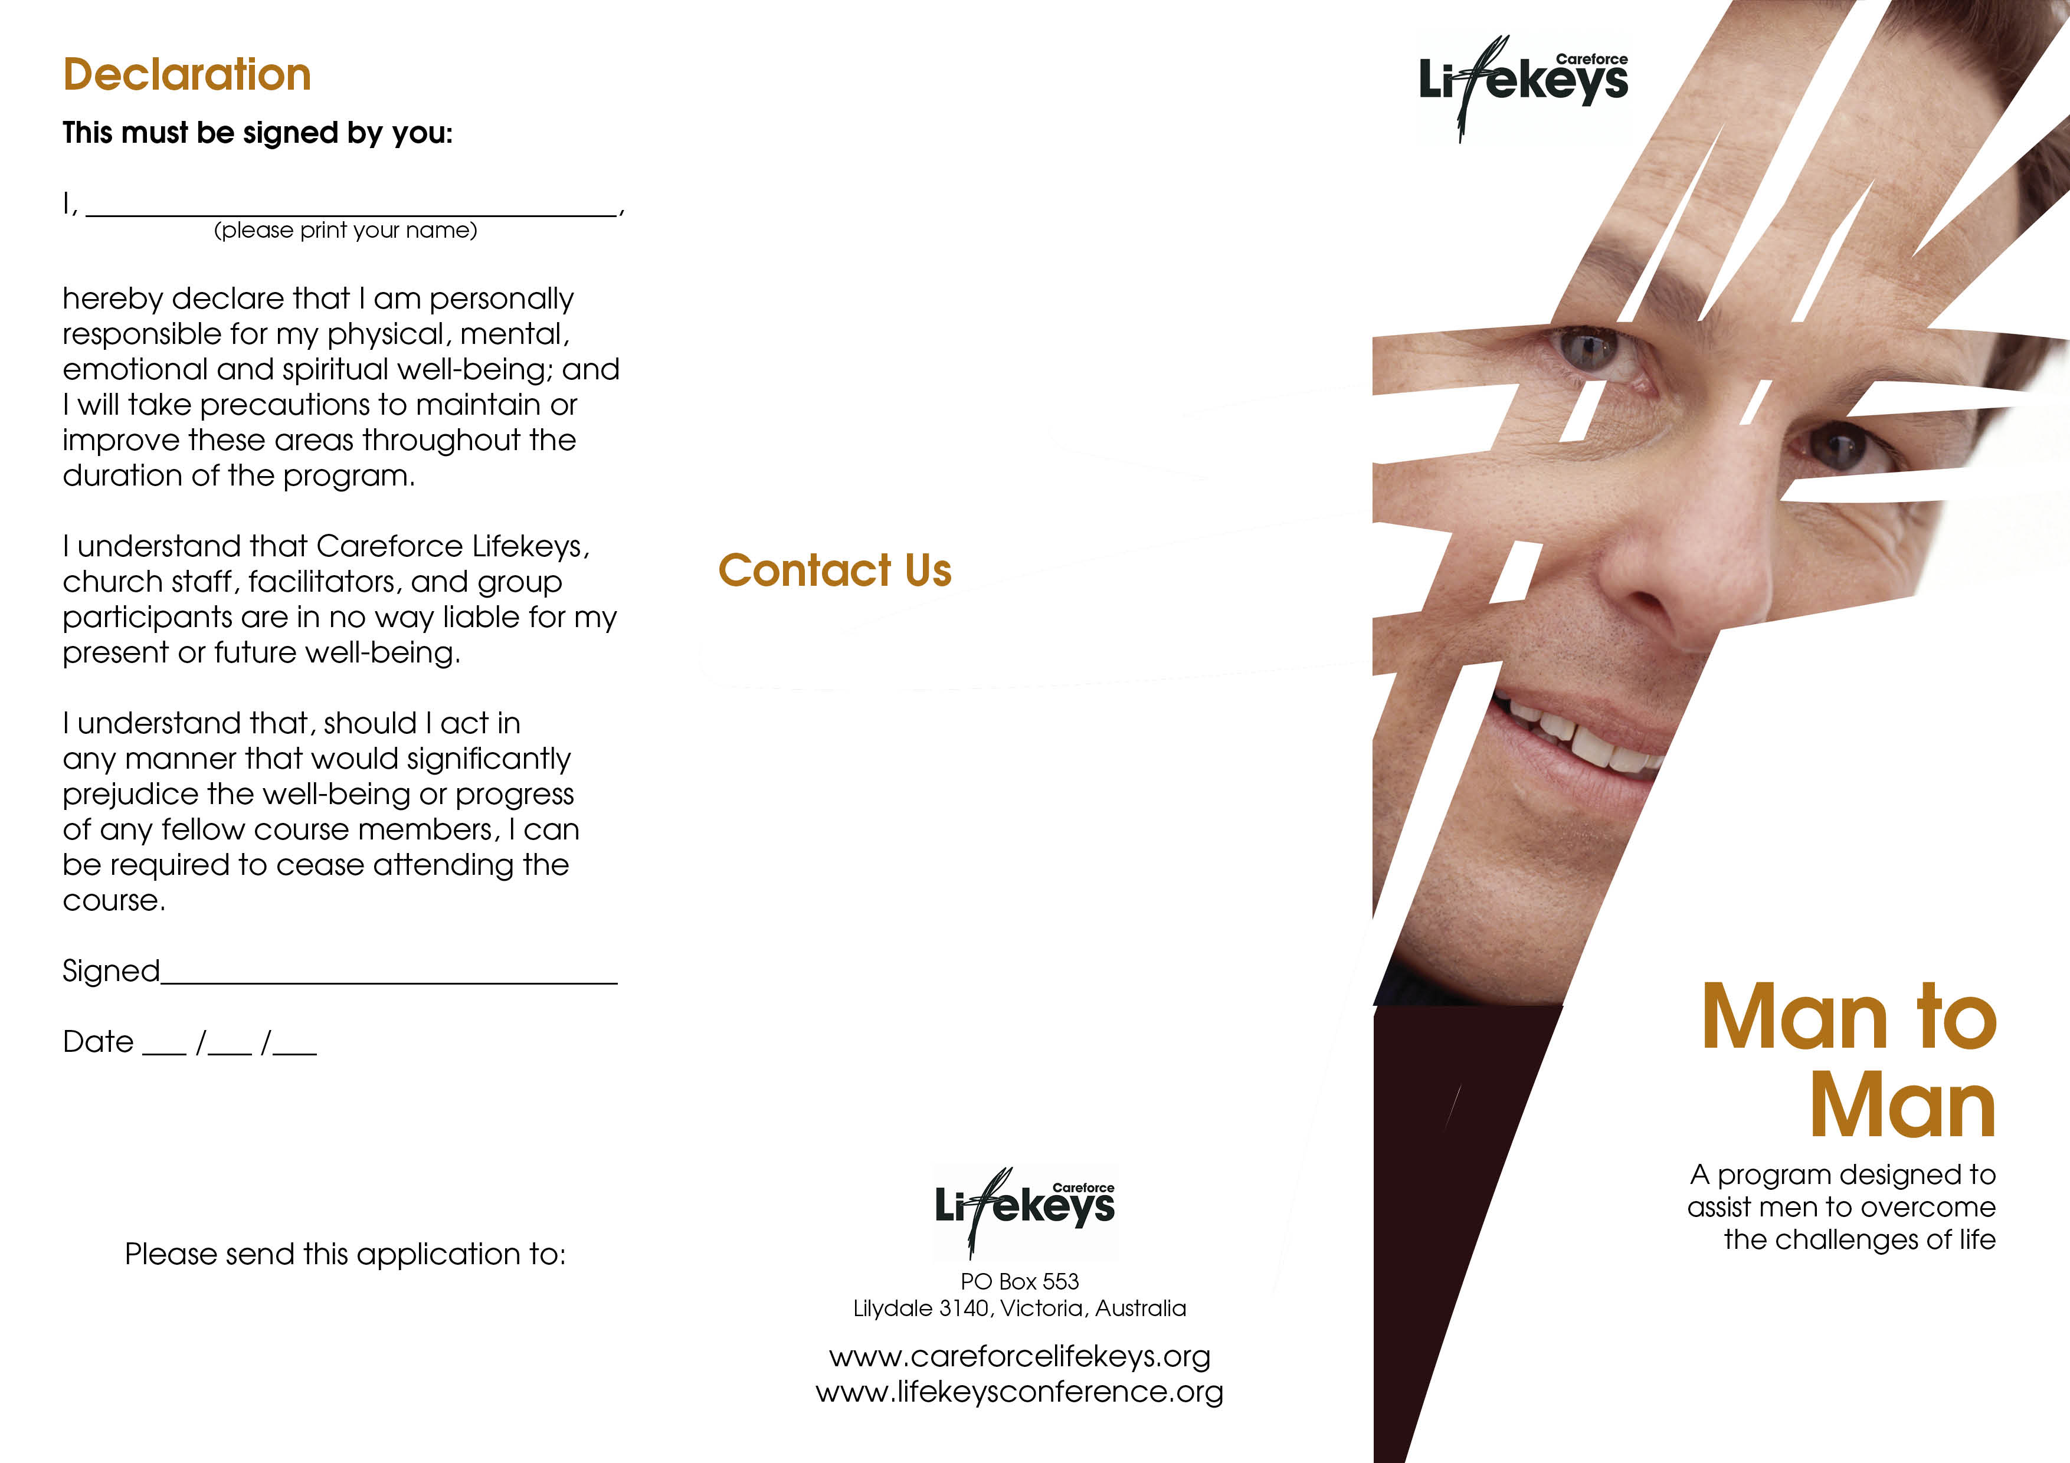

For more information about this program or other Lifekeys programs please contact Careforce Lifekeys

Phone: 03 9727 9638
Fax: 03 9727 1081
Email: info@careforcelifekeys.org

Your Organisation
PO Box 000
Hometown, 3333

Term 1
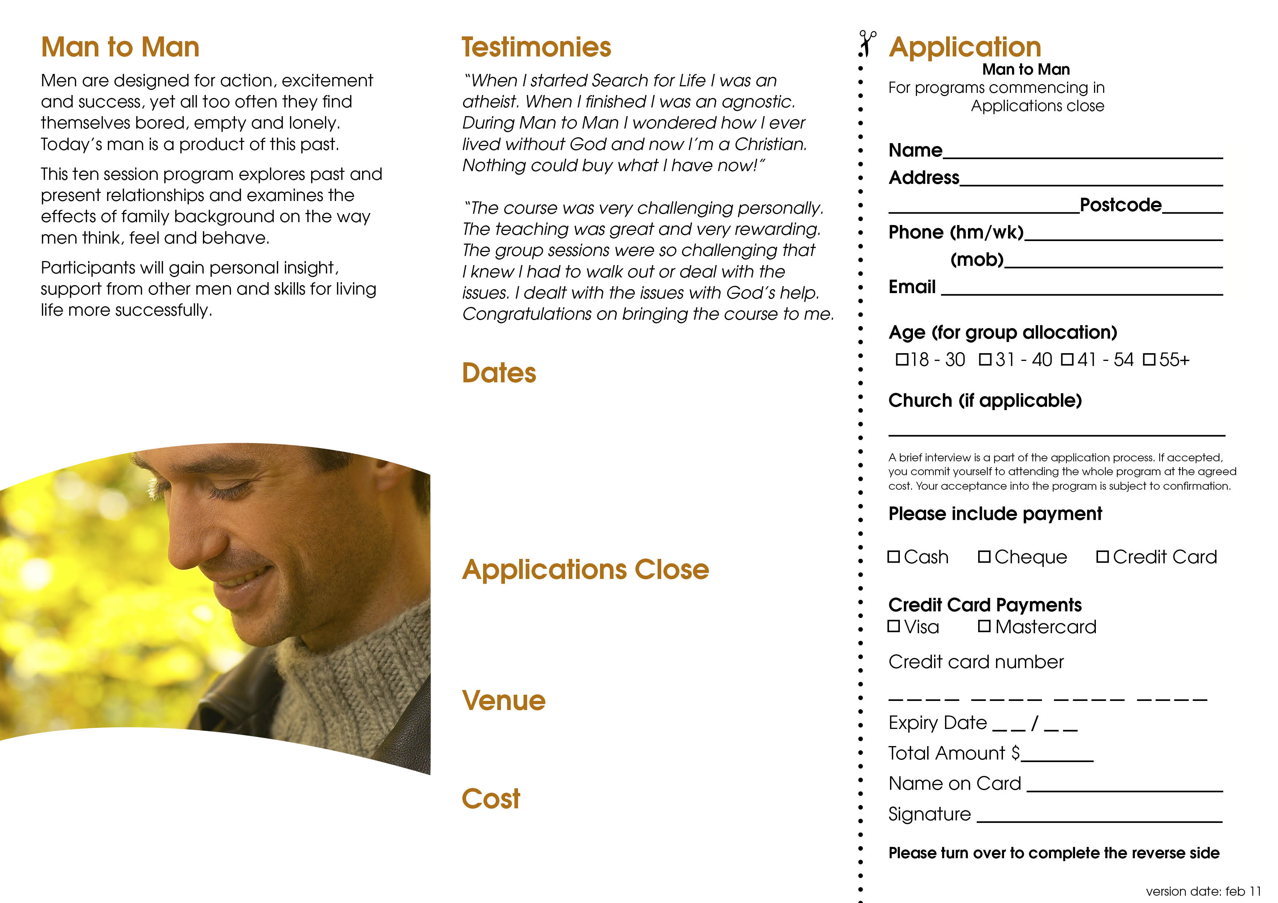
Tuesdays 22nd April – 24th June
9am – 11am
Tuesday 15th April
Your Organisation
77 Church St, Hometown

$77 per person
15th April
$66 per person
Cheques are payable to Careforce Lifekeys
Term 1, 2007

