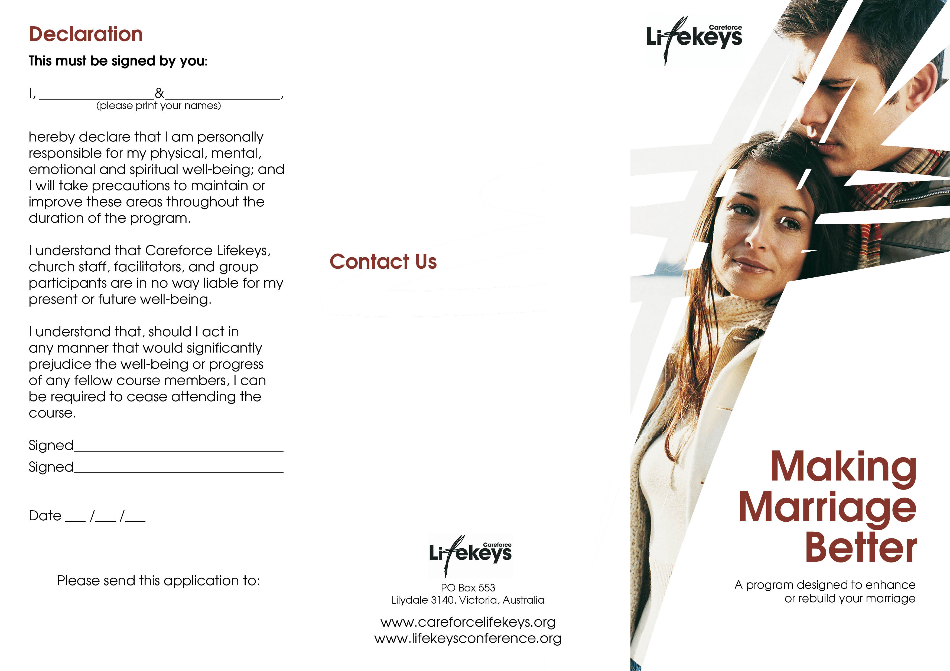
Your Organisation
PO Box 000
Hometown, 3333

Term 1

For more information about this program or other Lifekeys programs please contact Careforce Lifekeys

Phone: 03 9727 9638
Fax: 03 9727 1081
Email: info@careforcelifekeys.org

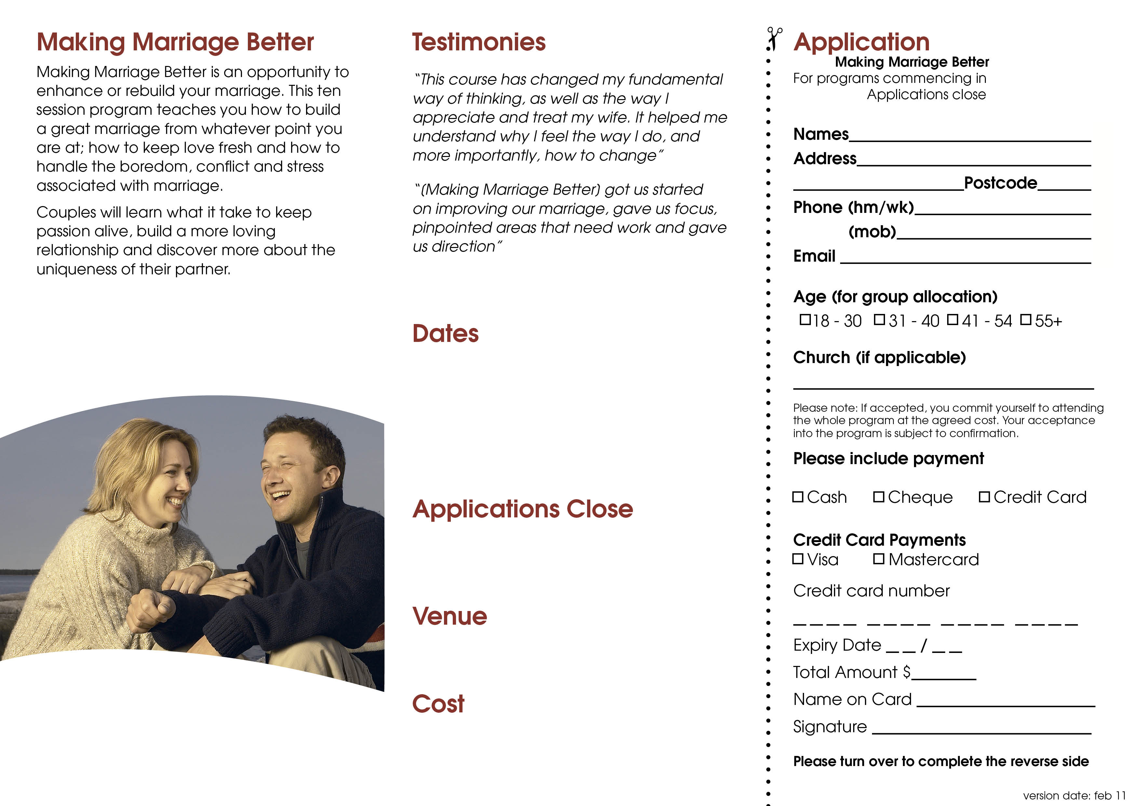
Tuesdays 22nd April – 24th June
9am – 11am
Tuesday 15th April
Your Organisation
77 Church St, Hometown
$77 per couple
Term 1, 2007
15th April
$77 per couple
Cheques are payable to Careforce Lifekeys

