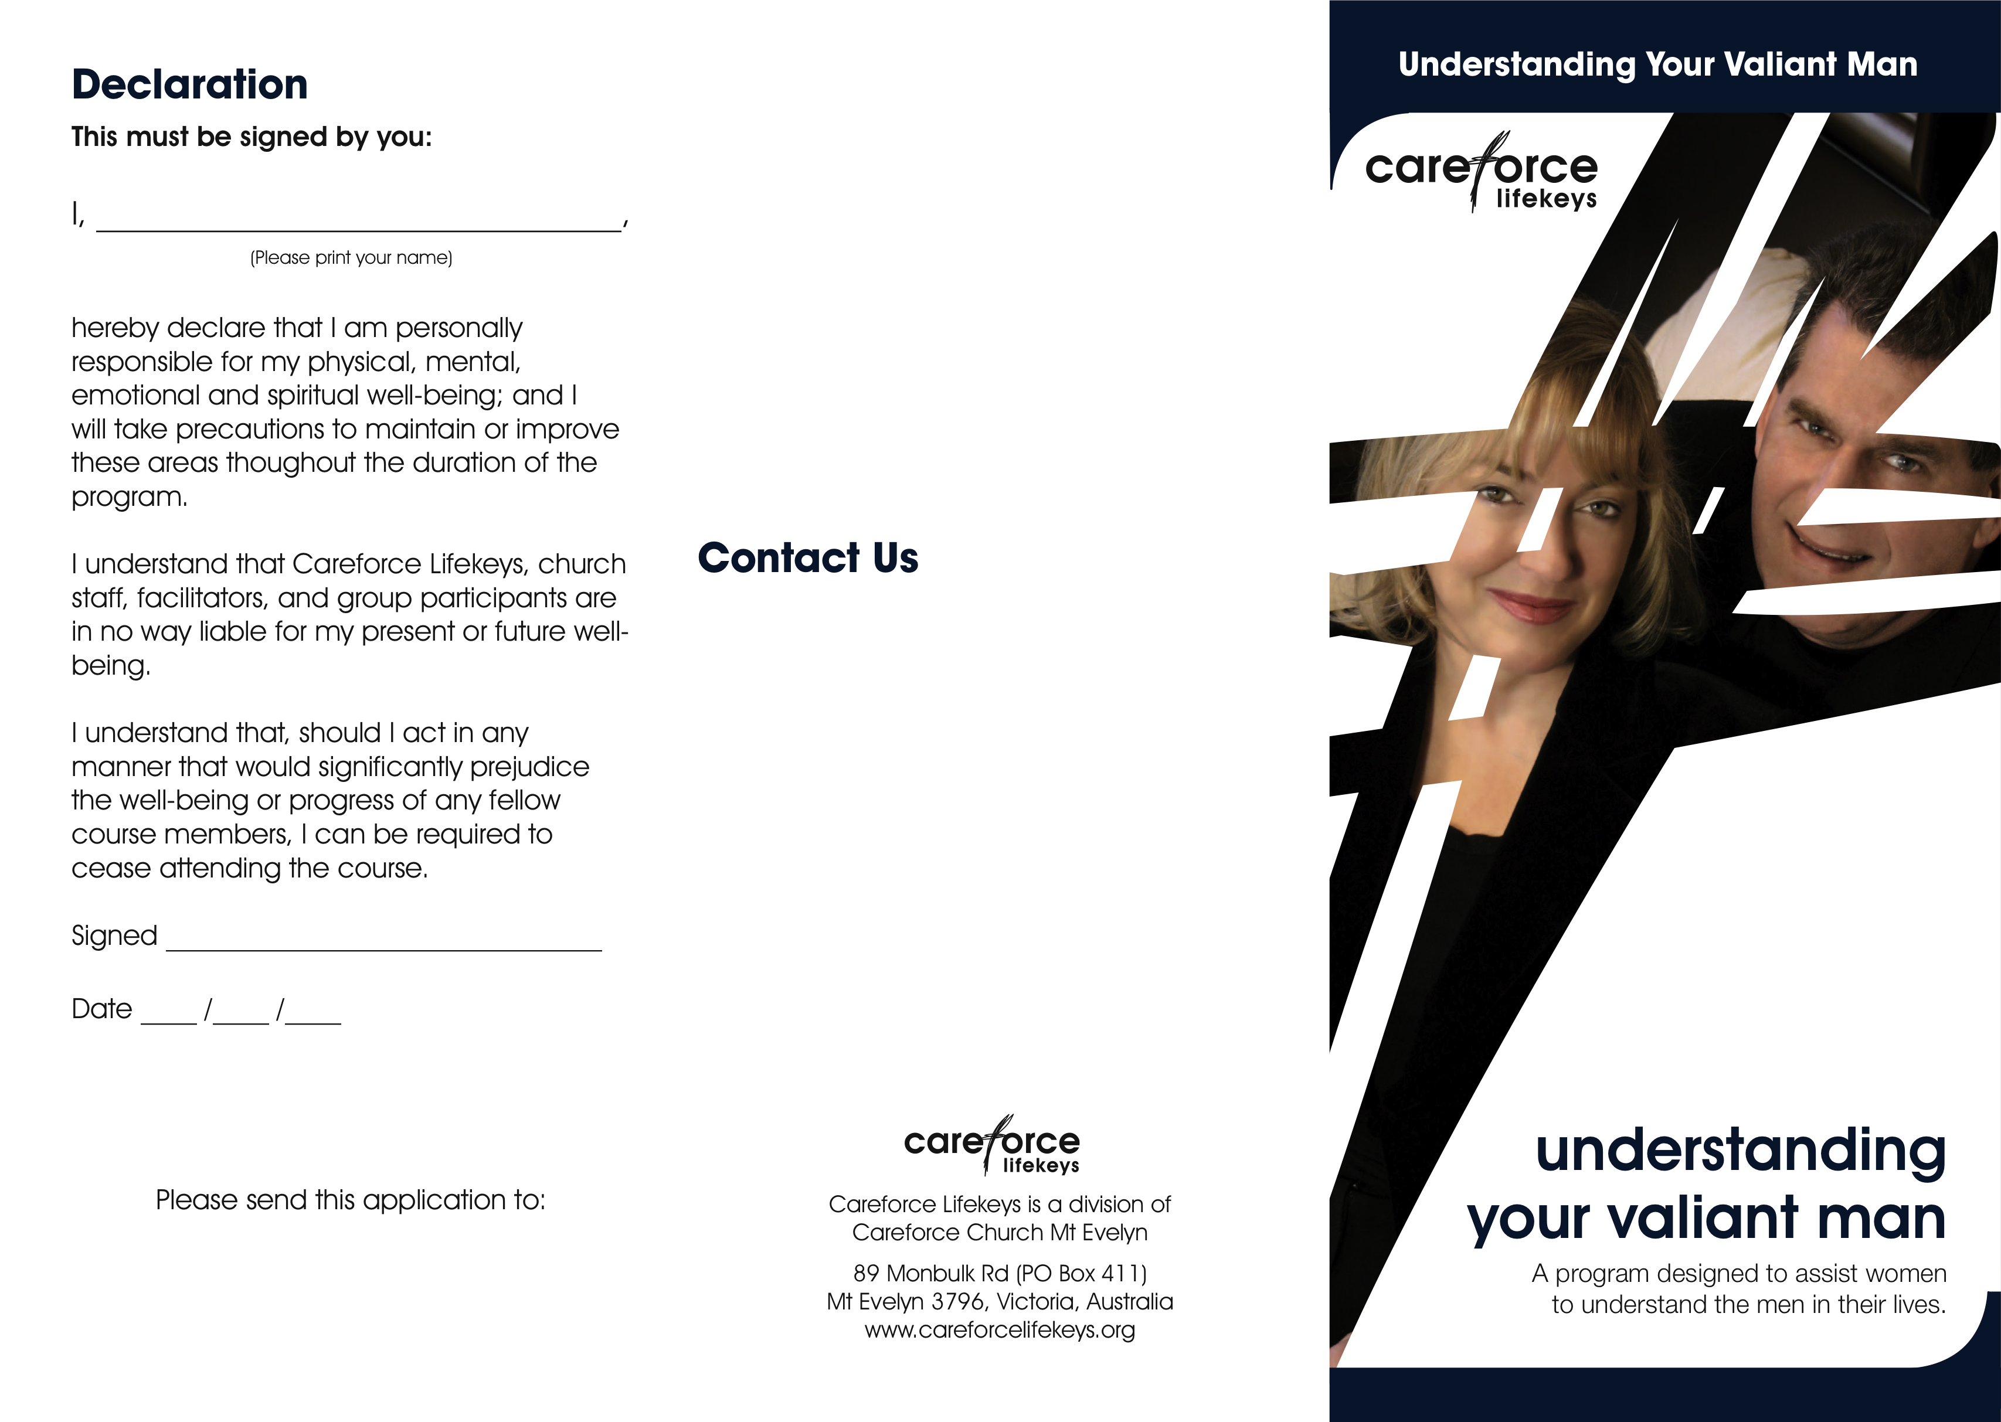
Term 1
For more information about this program or other Lifekeys programs please contact Careforce Lifekeys

Phone: 03 9736 2273
Fax: 03 9737 0781
Email: Lifekeys@careforce.org

Careforce Lifekeys
PO Box 411
Mt Evelyn, 3796
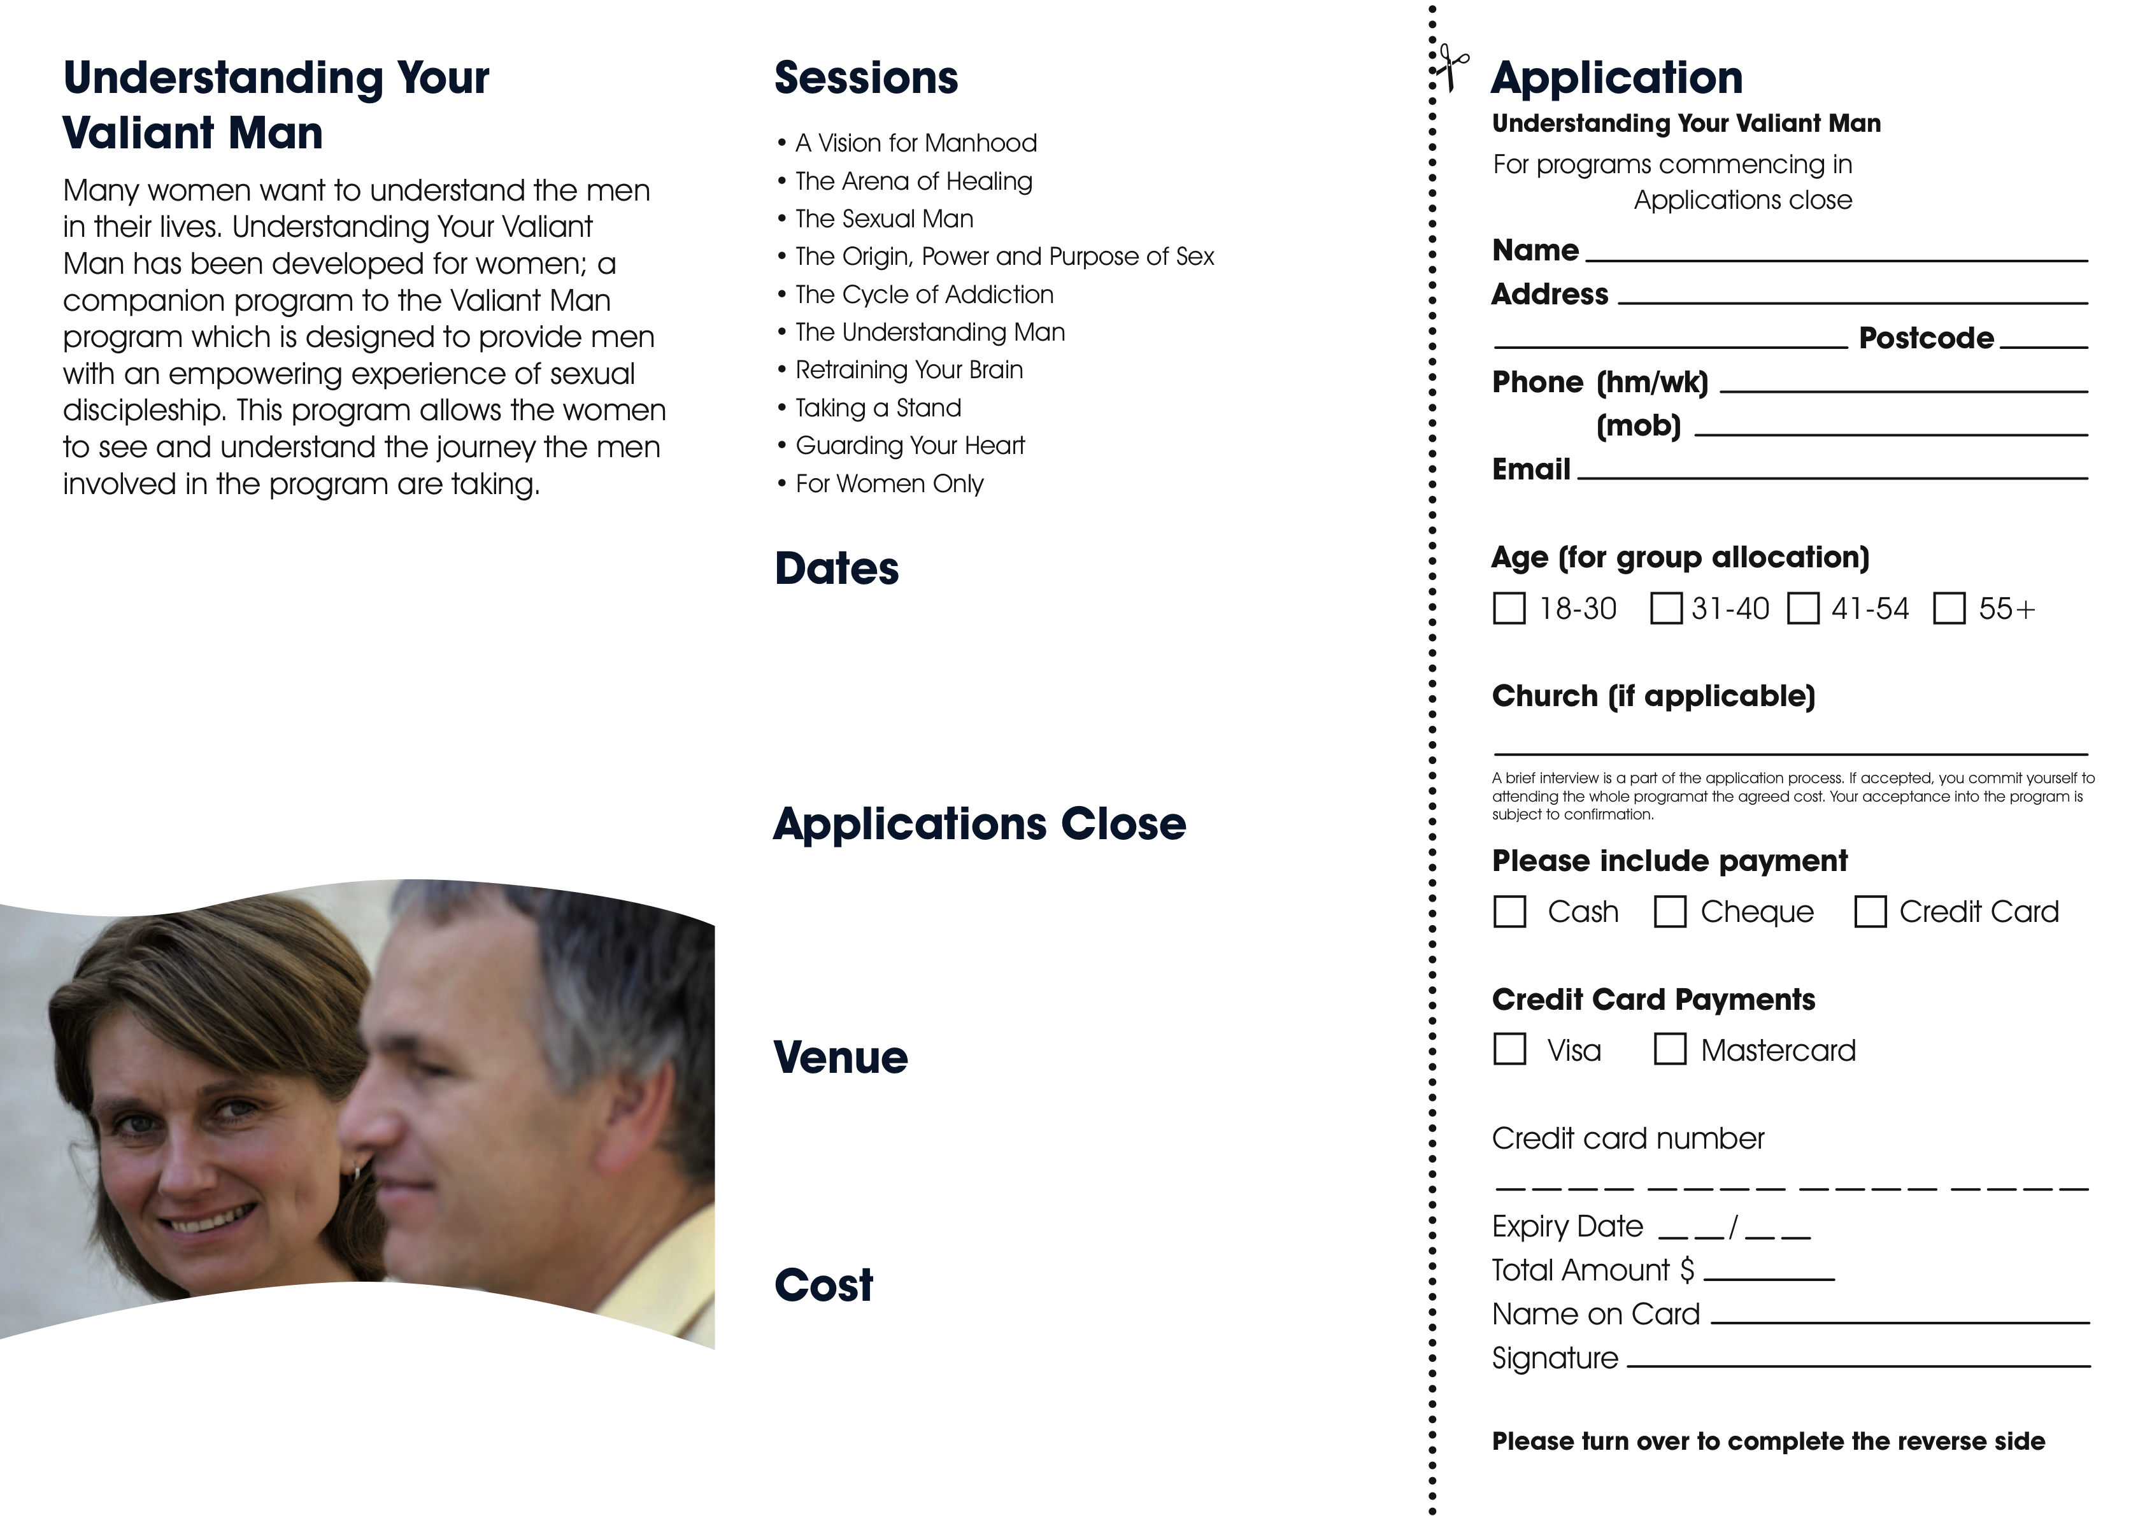
Term 1, 2007
15th April
version date: Aug ‘09
$77 per couple
Cheques are payable to Careforce Lifekeys
Tuesdays 22nd April – 24th June
9am – 11am
Tuesday 15th April
Careforce Church
89 Monbulk Rd, Mt Evelyn
$77 per couple

