

Term 1

Your Organisation
PO Box 000
Hometown, 3333

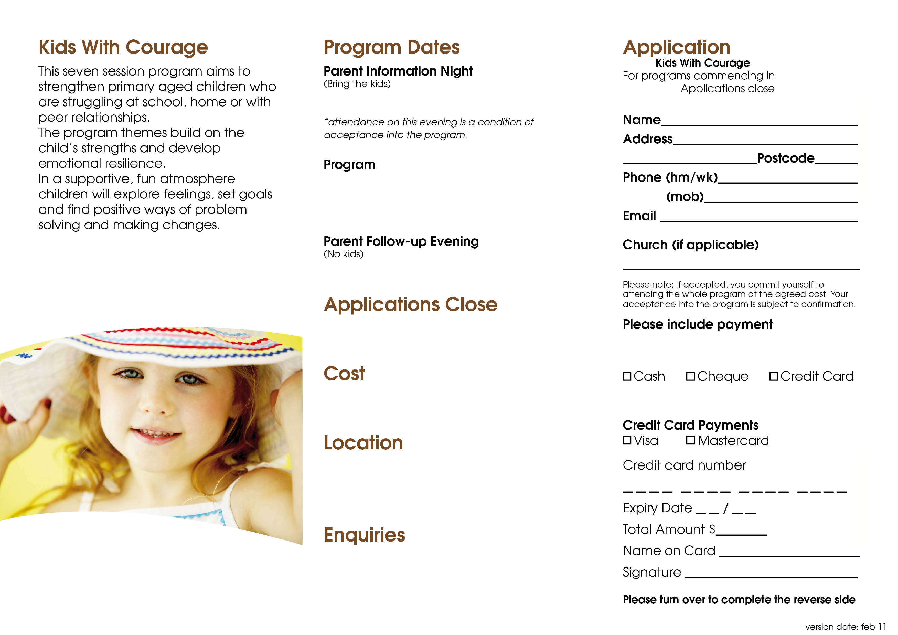
Tuesday 6th February at 7:30pm

Careforce Church Mt Evelyn
89 Monbulk Road
Mt Evelyn 3796
$66 per family
$44 per family concession price
Tuesday 27th March at 7:30pm
Thursdays, 2pm – 4pm
8th February – 22nd March
Tuesday 10th March
15th April
$66 per person
Cheques are payable to Careforce Lifekeys
Term 1, 2007
Phone: 00 0000 0000
Fax: 00 0000 0000
Email: email@email.com

Please note, this program is open to children in grades 2 - 6

